**Project plan:**

**Project topic:** Electronic message board

**Objectives:**

* Display 3 or more message
  + Our name with SID
  + A photo (maybe)
  + A gif (maybe)
* Use the 16x16 LED display to display message
* Use the 8 input buttons to switch messages

**Functional specifications:**

* Use the 8 input buttons as input device
* Use the 16x16 LED display as output device
* PORTA connects to the 8 input buttons
* PORTB connects to the 3-8 decoder of the 16x16 LED display
* PORTC and PORTD connects to the 16x16 LED display
* Display a null message when the program starts
* When buttons on the 8 input buttons is pressed
  + Display messages on 16x16 LED display

**System framework:**

**Flowchart**

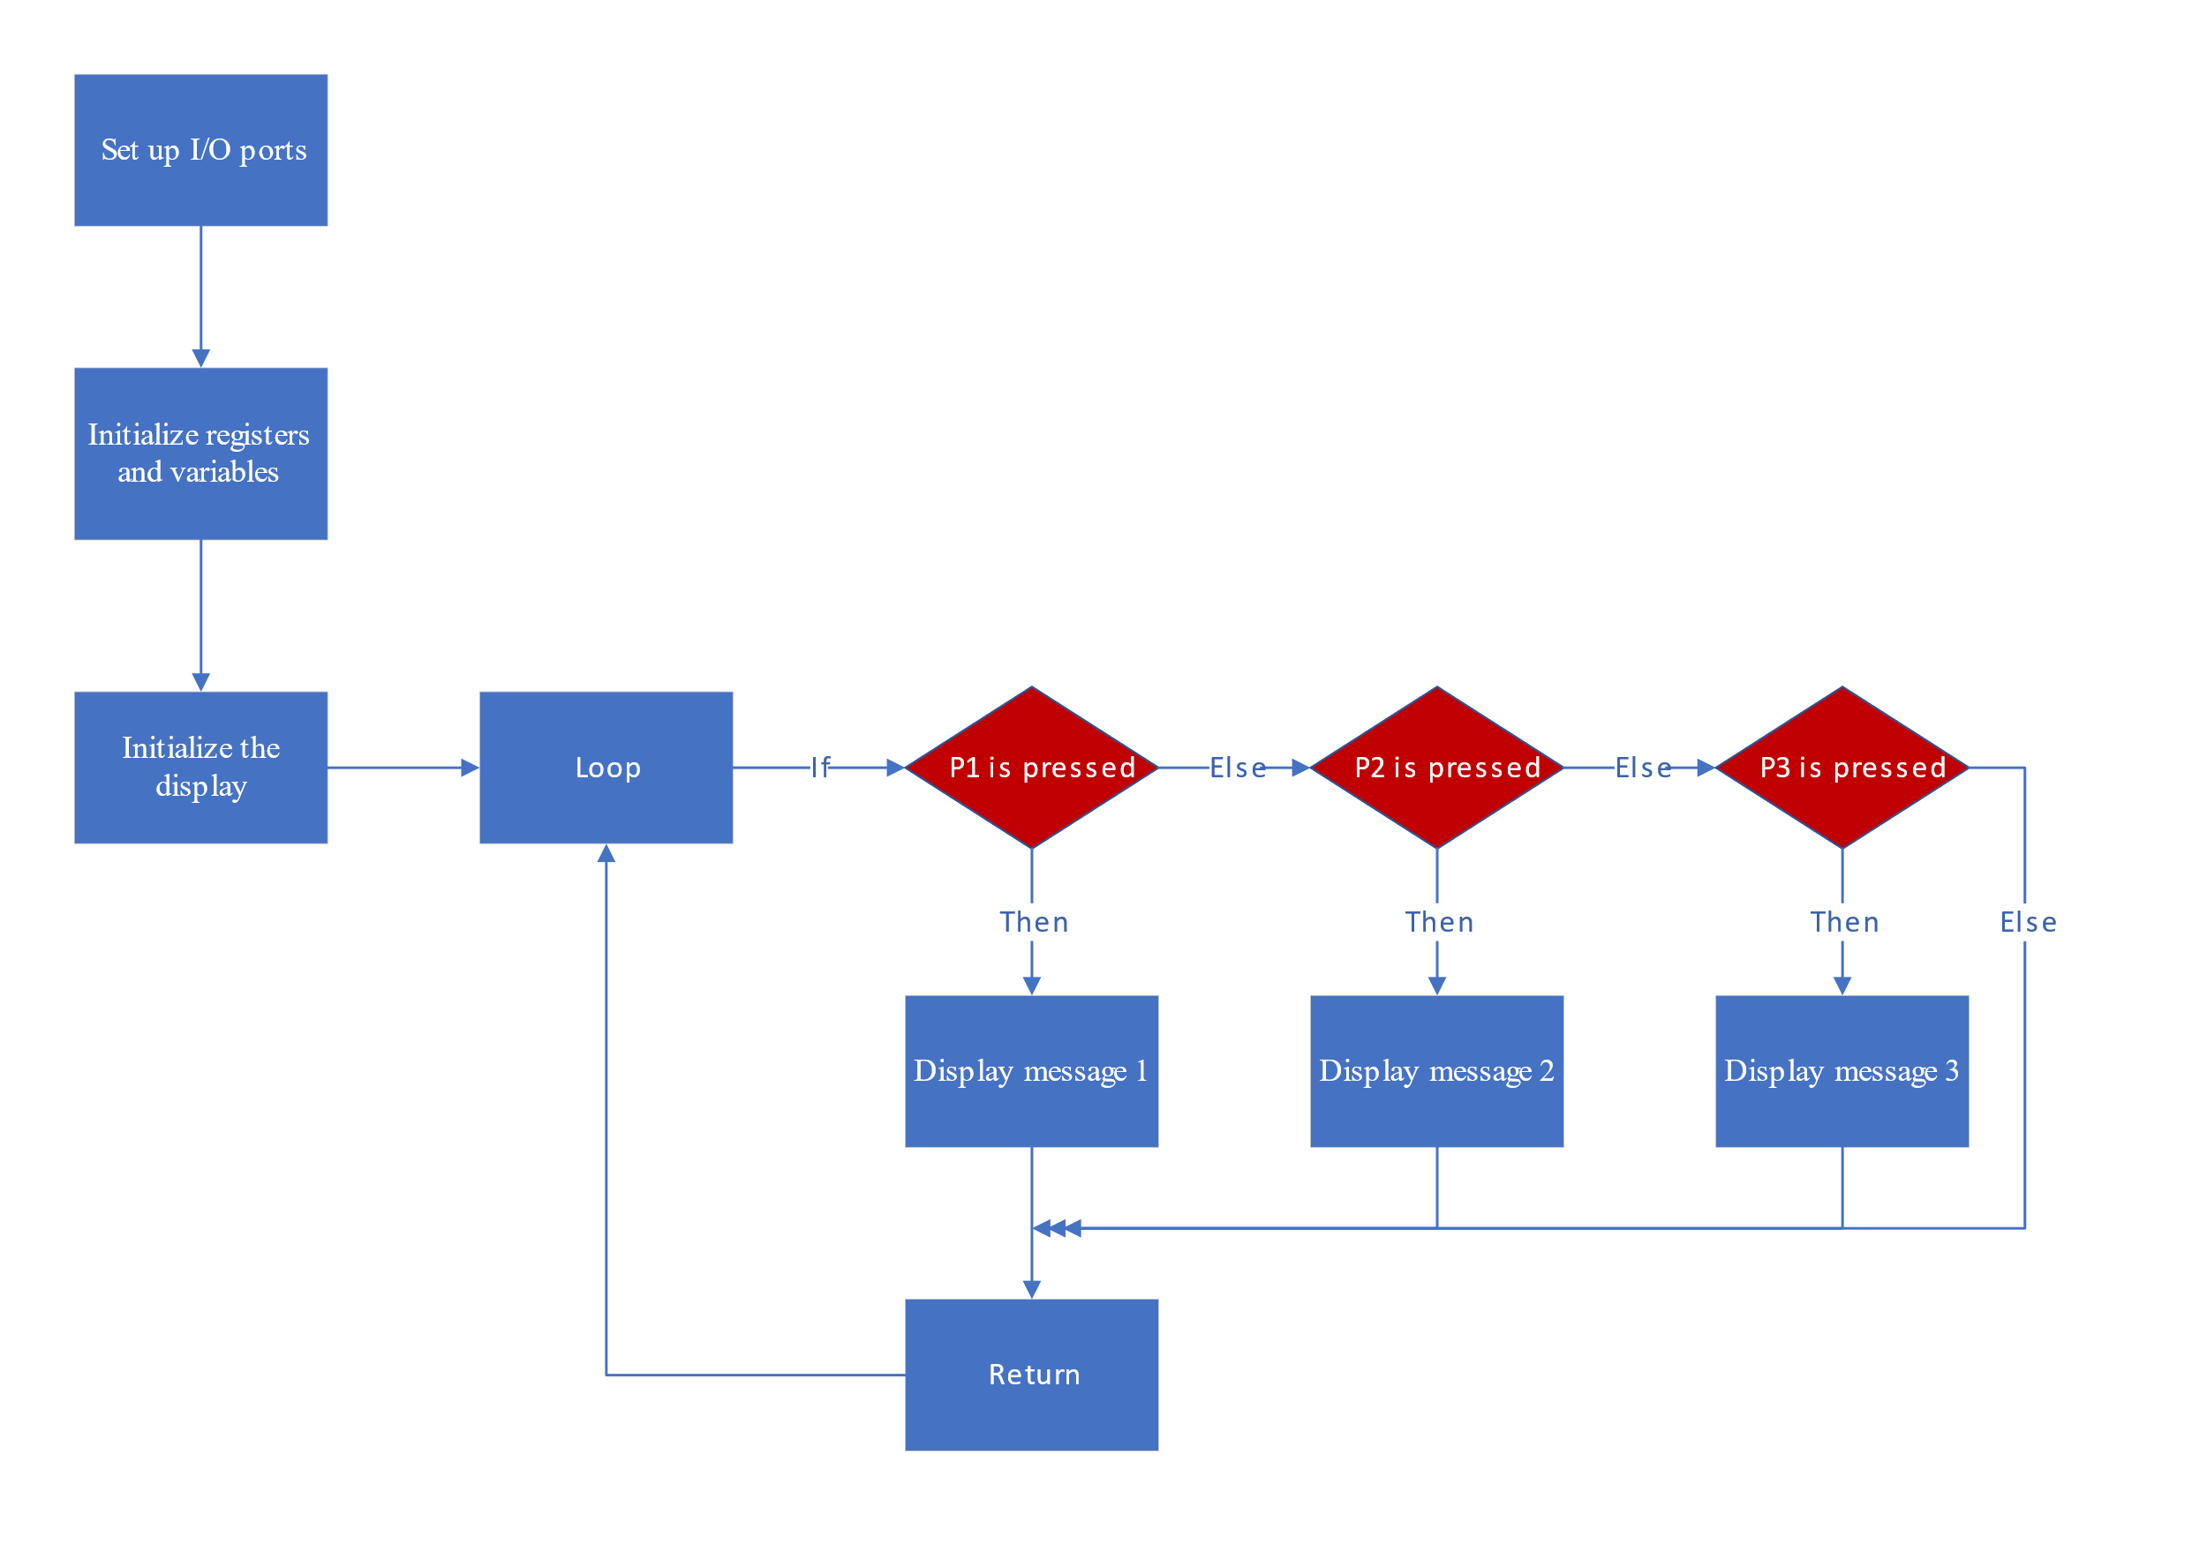

**Pseudo Code**

Set up I/O ports

Set TRISB TRISC TRISD to 0

Set TRISA to 1

Initialize registers and variables

Initialize the display (reset all display to off)

Loop:

If P1 is pressed

Call function to display message 1

Call delay function

Wait for P1 button up

Call delay function

If P2 is pressed

Call function to display message 2

Call delay function

Wait for P2 button up

Call delay function

If P3 is pressed

Call function to display message 3

Call delay function

Wait for P3 button up

Call delay function

Goto Loop

Message x:

Select LED panels via PORTB

Reset PORTC and PORTD

Display message via PORTC or PORTD

…x16 times…

Select LED panels via PORTB

Reset PORTC and PORTD

Display message via PORTC or PORTD

Return

END

**Responsible tasks:**

* Fill in the project plan: Leung Chun Wai and Tsoi Ho Wing
* Coding and debugging: Leung Chun Wai